COMMUNICATE THE RESULTS REPORT

Introduction

Seattle, Washington is well-known as a rainy city but does it in fact get more precipitation than other city? I was living in Spokane for around 2 years before moving to Seattle and this is my second year living here. For me, Spokane seems to receive more precipitation comparing to Seattle. However, using only my personal experience is not convincing enough. Therefore, I used the precipitation records from 2018 through 2022 to examine which city receives more precipitation on an average day, and which city experiences precipitation more often. Also, I explored the changes throughout the year.

Data and Methods

I used a cleaned CSV file with 3,590 daily observations including 1,795 for Seattle and 1,795 for Spokane for this analysis. The record identifies a date, city and precipitation amount in inches. I used Python to organize the data, then summarize daily precipitation and create graphs. When a day has a recorded precipitation that was greater than zero, that day was counted as a precipitation day.
I compared the mean daily precipitation and the percentage of precipitation days in each city. Also, I calculated the monthly averages and assessed monthly statistical tests in the notebook. The tests help examine whether differences in the observed data are significantly larger than might be expected from random variation.

Results

The mean for Seattle’s was 0.114 inches and only 0.064 inches in Spokane. This makes a difference of approximately 0.049 inches per day. Seattle’s average was about 77% higher. Therefore, Seattle received more precipitation on average day. In addition, the monthly chart shows that the gap was larger in the wetter months and smaller during summer.

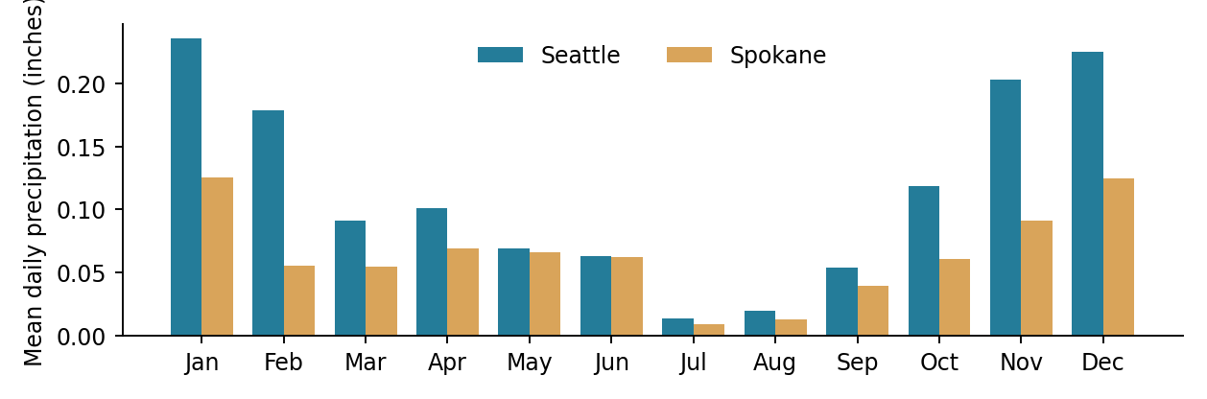
Figure 1. Average daily precipitation by calendar month, pooled across 2018–2022.
How often did the precipitation occur?

Seattle also experienced more days with measurable precipitation. Precipitation fell on roughly 54.2% of Seattle days, compared to 39.9% of Spokane days. That's about a 14.2 percentage point difference. This is significant because a city can receive more precipitation through frequent wet days or a smaller number of heavier events; the frequency comparison indicates that Seattle was wetter by both measures in this dataset.

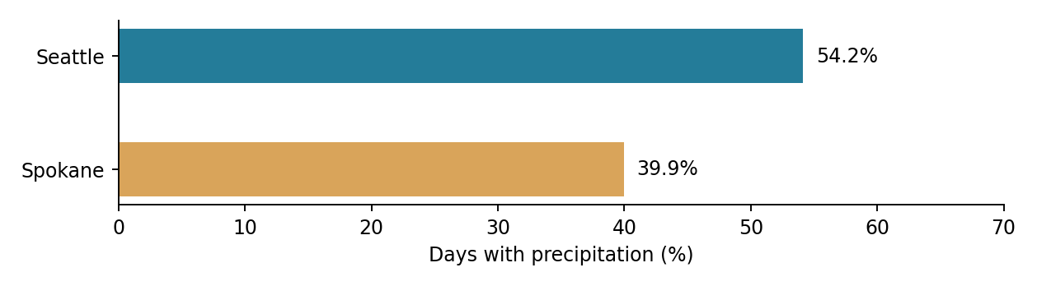
Figure 2. Percentage of observed days with precipitation greater than zero.

Seasonal Patterns and Statistical Tests

Monthly comparisons reveal that the difference between Seattle and Spokane was not consistent throughout the year. Mean daily precipitation in Seattle was generally higher in the fall and winter, while summer differences were less noticeable. The notebook also uses monthly two-sample tests of mean precipitation and proportion of wet days, with a 0.05 significance level. These results help in identifying months with stronger evidence of a difference, but due to multiple monthly tests and day-to-day weather variability, individual p-values should be interpreted with caution.

Conclusion

Seattle received more rain than Spokane over the time period included by this dataset. Seattle had a higher mean daily precipitation (0.114 against 0.064 inches) and a higher proportion of days with precipitation (54.2% vs. 39.9%). The variations were most obvious during the wettest period of the year. These data corroborate Seattle's reputation for being rainier than Spokane, however they only describe specific observations rather than establishing that the same pattern occurs every year.

